Steps to install Jenkins In ec2 amazon instance :

1. Install java 11 or above(Jenkins support java 11, you not install install java 11 or above then Jenkins will not work)

yum install git java-1.8.0-amazon-corretto.x86_64 maven  
  
here I am installing git and maven with java.

To check version type below :  
> java –version  
>git –version  
>mvn –version

1. Jenkins is service so for this goto Jenkins.io then selects “Red Hat/Fedora/Alma/Rocky/CentOS”.

sudo wget -O /etc/yum.repos.d/jenkins.repo https://pkg.jenkins.io/redhat-stable/jenkins.repo

sudo rpm --import <https://pkg.jenkins.io/redhat-stable/jenkins.io-2023.key>

1. If you have installed lower version of java and if you want to update java version then please type below cmd:  
     
   update-alternatives --config java  
     
   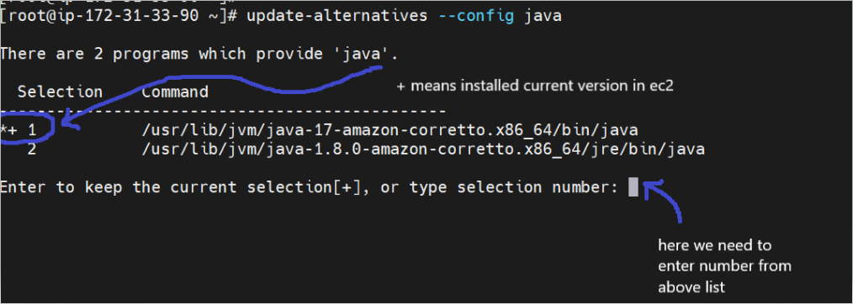
2. Install Jenkins :  
     
   yum install jenkins  
     
   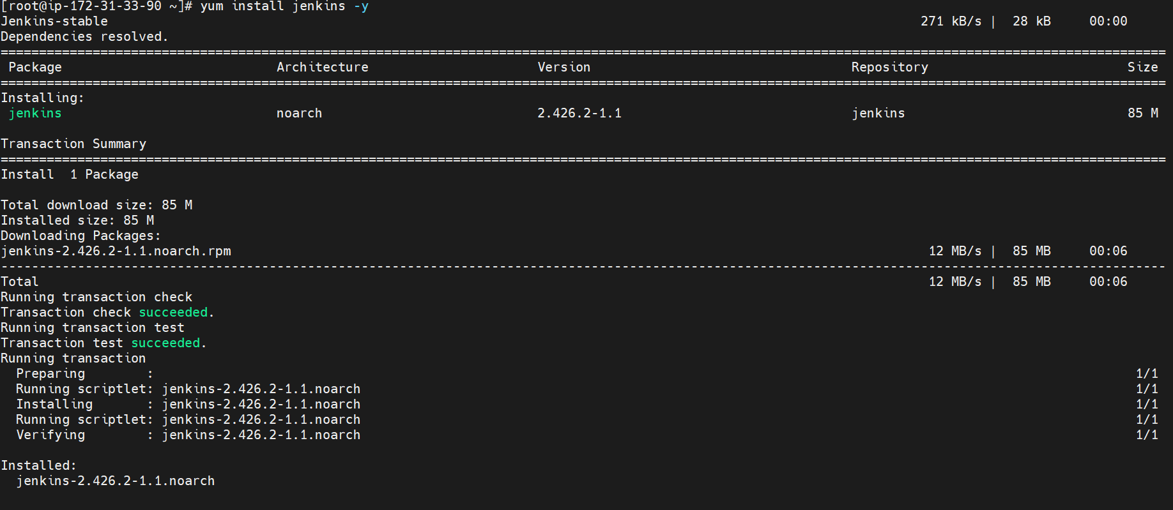
3. After installation start Jenkins :  
     
   systemctl start jenkins.service  
     
   
4. Check Jenkins service started or not :  
     
   systemctl status jenkins.service  
     
   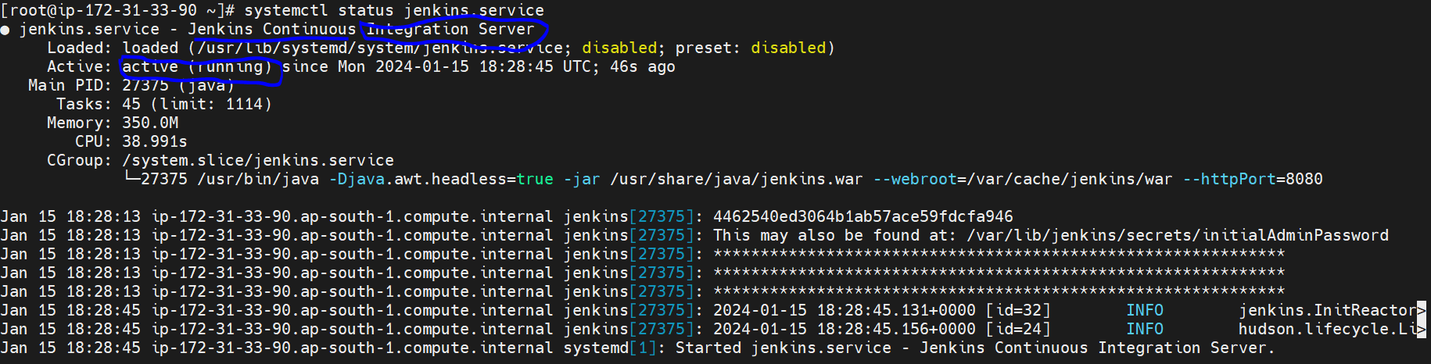
5. Copy public ip of your EC2 instance and paste in browser with 8080 port  
     
   <ec_2_public_ip>:8080  
     
   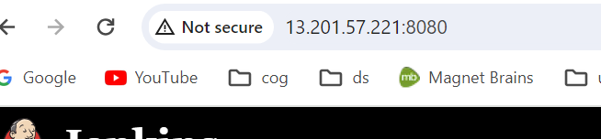
6. Then after that you need to copy secret or password, which you will get from below location :  
     
   cat /var/lib/jenkins/secrets/initialAdminPassword
7. Then create new user for Jenkins.